

Workers Compensation Injury Handbook

INJURIES, REPORT PROCEDURES & RISK MANAGEMENT

Dear Valued Client:

This letter is to introduce myself and welcome you to Howard Leasing’s Risk Management Department.

First, let’s make sure everyone has my contact information:

Sondra Kelley – Director of Risk Management
Office Phone: (941)761-7704
Cell Phone: (941) 932-5740
Fax Number: (941) 761-2559

This packet contains everything you will need in order to report any type of injury, whether it is a report only injury, first aid injury, and moderate to severe injuries. Please take note that no matter what type of injury it may be, even if the injured worker refuses treatment, a minimum of a 5 panel drug screen test must be performed within 24 hours. A 10 panel drug screen is preferred.

Please review the enclosed documents in this packet to familiarize yourself with our procedures. In the event of an injury, knowing what to do is critical to everyone.

This packet should contain the following documents:

1. INJURY REPORTING PROCEDURES
2. LOCATING AN URGENT CARE/MINOR EMERGENCY FACILITY
2. WORKERS’ COMPENSATION INFORMATION
3. FIRST REPORT OF INJURY OR ILLNESS
4. EMPLOYEE VERIFICATION FORM (ENGLISH AND SPANISH)
5. WITNESS STATEMENT (ENGLISH AND SPANISH
6. WORKERS’ COMPENSATION QUESTIONNAIRE
7. ACKNOWLEDGEMENT OF REFUSAL OF MEDICAL TREATMENT (ENGLISH AND SPANISH)
8. AUTHORIZATION FOR RELEASE OF INFORMATION

Please advise your supervisors and employees of these procedures.

Thank you for being a part of the Risk Management Team! Together we can work to make the workplace a safe environment!

Sincerely,
Sondra Kelley
Director of Risk Management

INJURY REPORTING PROCEDURES

IF THE INJURY IS AN EMERGENCY, DIAL 911 IMMEDIATELY. After calling 911, please contact Sondra Kelley as soon as possible at (941) 761-7704 between the hours of 8:00 AM and 5:00 PM. After hours you may reach Sondra Kelley at cell number (941) 932-5740. This number is available 7 days a week and 24 hours a day.

IF THE INJURY IS NOT AN EMERGENCY

- Call Sondra Kelley immediately upon being notified of an injury at (941) 761-7704 (Office) or (941) 932-5740. The State requires we report the injury to the State within a small timeframe or a fine and/or penalty could be assessed to the onsite employer.
- Fill out the FROI (First Report of Injury Form – DFS-F2-DWC-1).
- The Howard Leasing Risk Management/Workers Compensation department will coordinate which clinic to send the injured worker to for evaluation and mandatory drug screen.
- A minimum of a 5 Panel Drug Screen is mandatory for all workers’ compensation claims whether the injured worker wants treatment or refuses treatment. A 10 Panel Drug Screen is preferred.
- The injured employee must have a drug screen within 24 hours of the injury or the claim can be denied. (If the injured worker reports the injury 24 hours after the injury, the injured worker is still required to submit to a drug screen immediately)
- The employee needs to complete and sign the FROI, employee verification form, the Workers’ Compensation Questionnaire, the Authorization for Release of Information, Workers’ Compensation False or Fraudulent Claims and the Medical Refusal if the injured worker is refusing treatment.
- If anyone witnessed the accident, secure the witness statement as soon as possible. The witness needs to complete the Witness Statement form.
- If possible, take photos of the accident site.
- Please forward all workers’ compensation correspondence relating to the injury to: skelley@howardleasinginc.com or facsimile number (941) 761-2559.

Please remember, it is imperative that you communicate any injuries to Howard Leasing as soon as you are notified by one of your employees that an injury has occurred. No matter how big or how small, call Howard Leasing immediately. With timely reporting, we will be able to assist your injured employee as efficiently as possible.

- LATE REPORTING OF AN INJURY COULD RESULT IN PENALITIES AND FINES FROM THE STATE.
- FAILURE TO SECURE A DRUG SCREEN IMMEDIATELY AFTER ANY INJURY MAY RESULT IN A DENIED CLAIM.
- PLEASE RETAIN ANY DEFECTIVE EQUIPMENT OR FAULTY MACHINES FOR INSPECTION.

If this is a life threatening emergency, he/she will need to go to the nearest hospital for treatment. If not, please follow the instructions below to locate an in-network First Treatment Site to send your employee to for medical treatment.

Please access www.coventrywcs.com. You will come to a screen that looks like the below screen:



Click on PROVIDER TOOLS located at the top middle area of the page.



The next screen will look like the following:

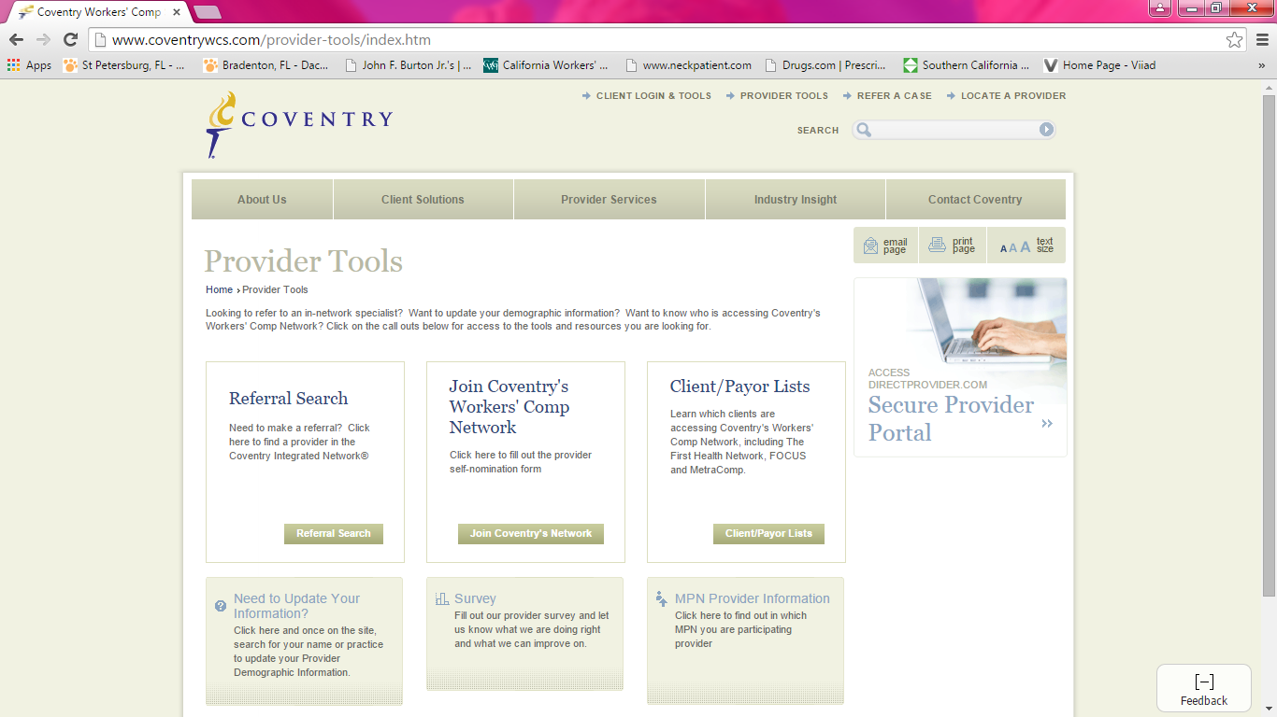

Click REFERRAL SEARCH

The next screen will look like the following:

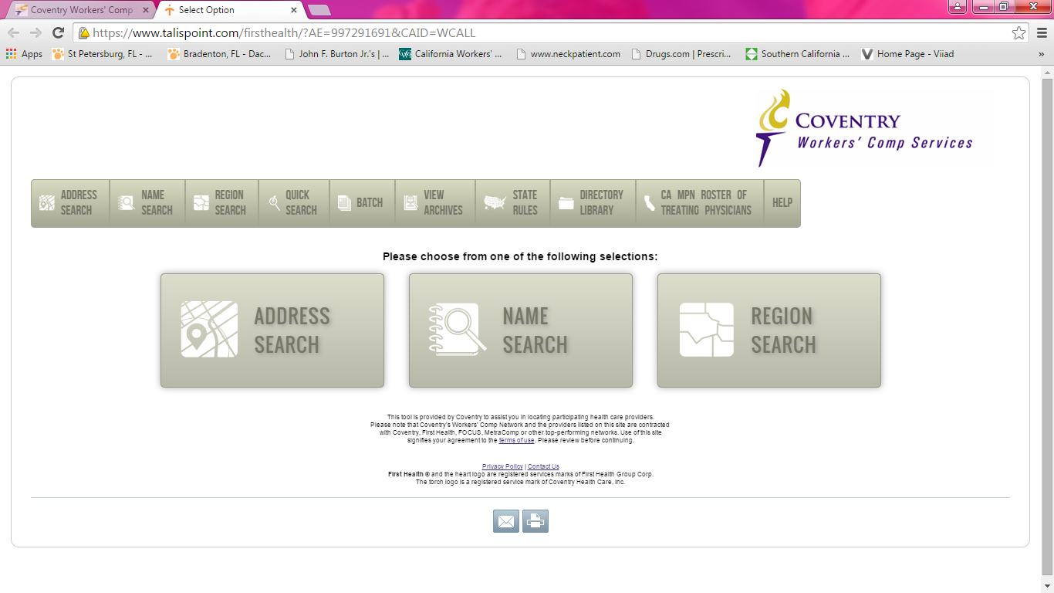

Select ADDRESS SEARCH to locate a FIRST TREATMENT SITE or a HOSPITAL/EMERGENCY ROOM closest to your address.

ENTER ADDRESS – you must enter a valid zip code or city and state in order to use this feature.

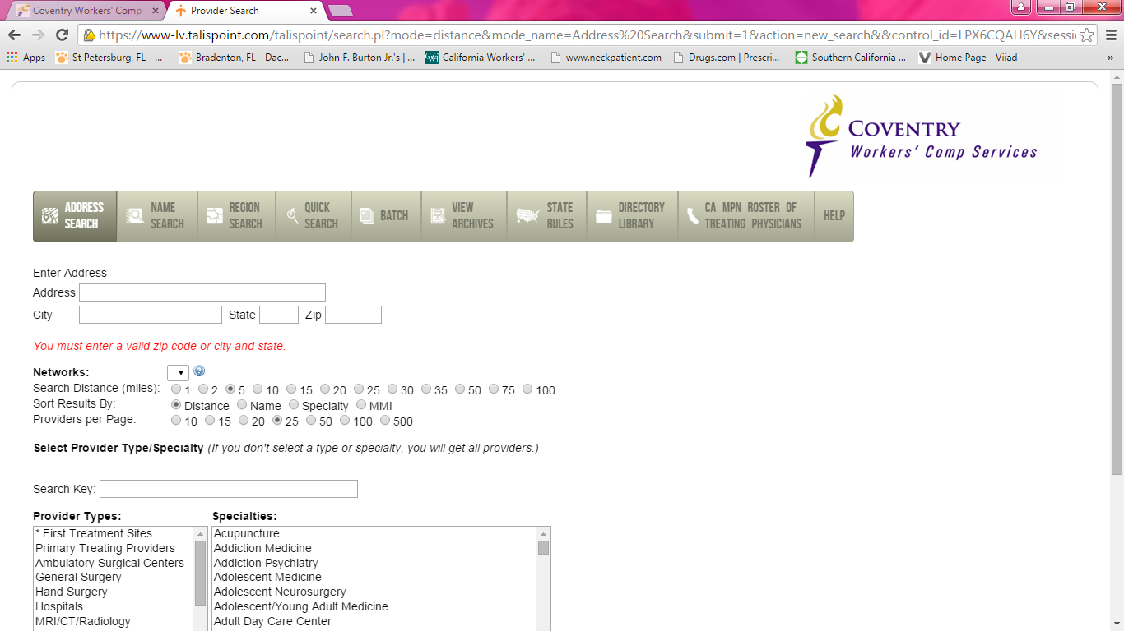

Select the distance you want to search from your location. The system is automatically set for five (5) miles. If you are in a more rural area you may want to expand it to more than 20 miles from your location.

To locate a First Treatment Site (walk in clinics/urgent care clinics), select *First Treatment Sites.

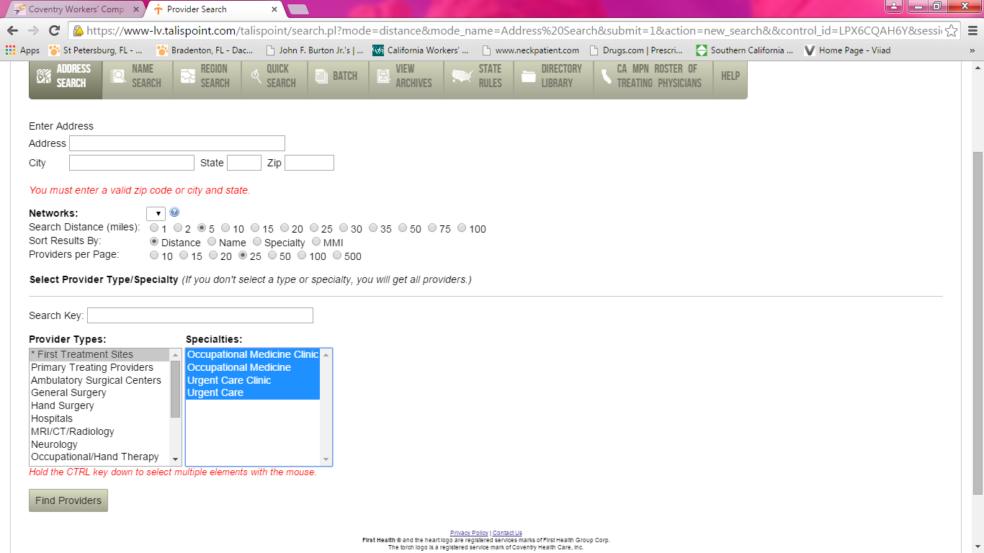

Hold the CTRL key down and select each type of First Treatment Sites to enable a wider search.

Then select FIND PROVIDER

The next screen will provide with the name, location, distance, and phone number.

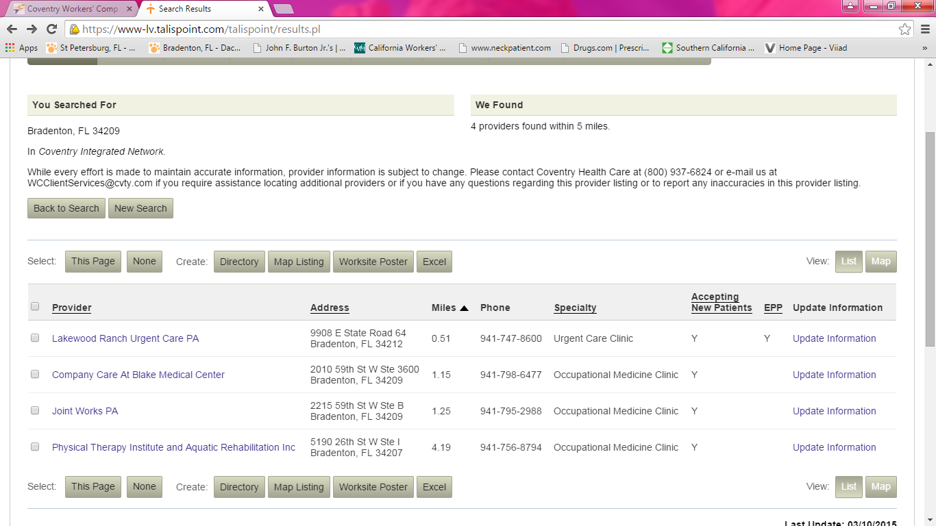

Please make sure you are sending your employees to someone in the network. Your employee MUST be drug tested at this location. We prefer a 10 panel drug screen, if that is not available a minimum of a 5 panel drug screen is required.

If you have any questions feel free to contact Howard Leasing.

HOWARD LEASING, INC
WORKERS’ COMPENSATION INFORMATION

SUNZ INSURANCE COMPANY
TPA: North American Risk Services
PO BOX 16602
Altamonte Springs, FL 32716

POLICY NUMBER – WCPEO-000004006

Howard Leasing, Inc
6302 Manatee Avenue West, Suite K
Bradenton, FL 34209

Phone: (941) 761-7704
Fax: 941-761-2559
Attention: Sondra Kelley
SKelley@howardleasinginc.com
(941) 932-5740

If you have any questions please contact Sondra Kelley, Director of Risk Management, Howard Leasing, Inc.

FIRST REPORT OF INJURY OR ILLNESS | RECEIVED BY  CLAIMS-HANDLING ENTITY | SENT TO DIVISION DATE | DIVISION RECEIVED DATE

FLORIDA DEPARTMENT OF FINANCIAL SERVICES

DIVISION OF WORKERS' COMPENSATION

For assistance call 1-800-342-1741
or contact your local EAO Office
Report all deaths within 24 hours 1-800-219-8953 or (850) 922-8953

PLEASE PRINT OR TYPE EMPLOYEE INFORMATION
NAME (First, Middle, Last) |  | Social Security Number | Date of Accident (Month-Day-Year) |  | Time of Accident  AM PM
HOME ADDRESS  Street/Apt #: _________________________________________________________  City: _________________________ State: _______________ Zip: ______________ |  | EMPLOYEE'S DESCRIPTION OF ACCIDENT (Include Cause of Injury)
TELEPHONE Area Code Number

OCCUPATION |  | INJURY/ILLNESS THAT OCCURRED |  | PART OF BODY AFFECTED
DATE OF BIRTH  _________ / _________ / _________ | SEX  M F
EMPLOYER INFORMATION
COMPANY NAME: _HOWARD LEASING, INC_____________________  D. B. A.: ____________________________________________________________ | FEDERAL I.D. NUMBER (FEIN) | DATE FIRST REPORTED (Month/Day/Year)
Street: _6302 MANATEE AVENUE WEST, SUITE K__________  City: BRADENTON_______ State: FL_____________ Zip: _34209______ | NATURE OF BUSINESS | POLICY/MEMBER NUMBER  WCPEO-000004005
TELEPHONE Area Code Number  941-761-7704 | DATE EMPLOYED  _________ / _________ / _________ | PAID FOR DATE OF INJURY  YES NO
EMPLOYER'S LOCATION ADDRESS (If different)  Street: _____________________________________________________________ | LAST DATE EMPLOYEE WORKED  _________ / _________ / _________ | WILL YOU CONTINUE TO PAY WAGES INSTEAD OF WORKERS' COMP? YES
City: ________________________ State: _______________ Zip: ______________  LOCATION # (If applicable) ____________________________________________ | RETURNED TO WORK YES NO  IF YES, GIVE DATE  _________ / _________ / _________ | LAST DAY WAGES WILL BE PAID INSTEAD OF  WORKERS' COMP  _________ / _________ / _________
PLACE OF ACCIDENT (Street, City, State, Zip)  Street: _____________________________________________________________ | DATE OF DEATH (If applicable)  _________ / _________ / _________ | RATE OF PAY  $ _________________ PER | HR WK  DAY MO
City: _________________________ State: _______________ Zip: ______________  COUNTY OF ACCIDENT ______________________________________________ | AGREE WITH DESCRIPTION OF ACCIDENT?  YES NO | Number of hours per day  Number of hours per week  Number of days per week | ______________________  ______________________  ______________________
Any person who, knowingly and with intent to injure, defraud, or deceive any employer or employee, insurance company, or self-insured program, files a statement of claim containing any false or misleading information commits insurance fraud, punishable as provided in s. 817.234. Section 440.105(7), F.S.  I have reviewed, understand and acknowledge the above statement.  __________________________________________________________________ _______________________________________________  EMPLOYEE SIGNATURE (If available to sign) DATE  __________________________________________________________________ _______________________________________________  EMPLOYER SIGNATURE DATE |  | NAME, ADDRESS AND TELEPHONE  OF PHYSICIAN OR HOSPITAL  AUTHORIZED BY EMPLOYER YES NO
CLAIMS-HANDLING ENTITY INFORMATION
1(a) Denied Case - DWC-12, Notice of Denial Attached 2. Medical Only which became Lost Time Case (Complete all required information in #3)
1(b) Indemnity Only Denied Case - DWC-12, Notice of Denial Attached Employee’s 8TH Day of Disability _________ / _________ / _________
Entity’s Knowledge of 8TH Day of Disability _________ / _________ / _________
3. Lost Time Case - 1st day of disability _________ / _________ / _________ Full Salary in lieu of comp? YES Full Salary End Date ________/ ________ / ________

Date First Payment Mailed _________ / _________ / _________ AWW ____________________________ Comp Rate ____________________________

T.T. T.T. - 80% T.P. I.B. P.T. DEATH SETTLEMENT ONLY

Penalty Amount Paid in 1st Payment $___________ Interest Amount Paid in 1st Payment $__________

REMARKS: |  |  | INSURER NAME  SUNZ INSURANCE
 |  |  | CLAIMS-HANDLING ENTITY NAME, ADDRESS & TELEPHONE
INSURER CODE #  1155 | EMPLOYEE'S CLASS CODE | EMPLOYER'S NAICS CODE | NARS  PO BOX 166002  Altamonte Springs, FL 32716  Ph: (877) 343-9844
SERVICE CO/TPA CODE # | CLAIMS-HANDLING ENTITY FILE #
Form DFS-F2-DWC-1 (08/2004)

DWC-1 Purpose and Use Statement
The collection of the social security number on this form is
specifically authorized by Section 440.185(2), Florida
Statutes. The social security number will be used as a unique
identifier in Division of Workers' Compensation database
systems for individuals who have claimed benefits under
Chapter 440, Florida Statutes. It will also be used to identify
information and documents in those database systems
regarding individuals who have claimed benefits under
Chapter 440, Florida Statutes, for internal agency tracking
purposes and for purposes of responding to both public
records requests and subpoenas that require production of
specified documents. The social security number may also be
used for any other purpose specifically required or
authorized by state or federal law.

EMPLOYEE VERIFICATION FORM
(TO BE FILLED OUT BY THE INJURED WORKER)

We are attempting to process your worker’s compensation claim and need to verify the following information in order for us to determine entitlement to workers compensation benefits.

Please verify that the following information is true and correct:

NAME: ______________________________________________________________

EMPLOYER NAME: __________________________________________________

SOCIAL SECURITY #: __________________________________________________

DATE OF BIRTH: _____________________________________________________

ADDRESS: ___________________________________________________________

PHONE NUMBER: _____________________________________________________

DATE OF INJURY: ______________________________________________________

In order to receive benefits for my worker’s compensation claim, I, ____________________, attest that
the above information is true and correct.

EMPLOYEE SIGNED NAME: ______________________________________

EMPLOYEE PRINTED NAME: ______________________________________

DATE: ______________________

Preparer and/or Translator Certification: (To be completed and signed if this form is prepared by a person other than the injured worker.)
I attest, under penalty of perjury, that I have assisted in the completion of this form and that the form was read and/or translated to the injured worker and the answers provided on this form was provided by the injured worker.

Name: ___________________________________________ Date: _________________________

Address: _________________________________________________ Ph: ____________________

Signature. ______________________________________________________

FORMULARIO DE VERIFICACIÓN DEL EMPLEADO
(PARA SER COMPLETADO POR EL TRABAJADOR LESIONADO)

Estamos tratando de procesar su reclamo de compensación al trabajador y necesitamos verificar la siguiente información para que podamos determinar el derecho a beneficios de compensación de trabajadores.

Por favor verifique que la siguiente información sea verdadera y correcta:

NOMBRE: ______________________________________________________________

NOMBRE DEL EMPLEADOR: ____________________________________________

NÚMERO DE SEGURO SOCIAL: __________________________________________

FECHA DE NACIMIENTO: _______________________________________________

DIRECCIÓN: ____________________________________________________________

NÚMERO DE TELÉFONO: _______________________________________________

FECHA DE LA LESIÓN: __________________________________________________

Con el fin de recibir beneficios por mi reclamo de compensación al trabajador, yo, __________________________________________ doy fe de que la información anterior es verdadera y correcta.

FIRMA DEL EMPLEADO: _________________________________________________

NOMBRE EN IMPRENTA DEL EMPLEADO: _________________________________

FECHA: _______________________________

Certificación del Preparador y / o Traductor: (Para ser completada y firmada si este formulario es preparado por una persona distinta al trabajador lesionado.)
Doy fe, bajo pena de perjurio, que he ayudado en la preparación de este formulario y que el formulario fue leído y / o traducido al trabajador lesionado y las respuestas dadas en este formulario fueron proporcionadas por el trabajador lesionado.

Nombre: ___________________________________________ Fecha: _________________________________

Dirección: ___________________________________________ Número de Teléfono: _____________________

Firma Del Preparador y / o Traductor: ______________________________________________________

WORKERS’ COMPENSATION QUESTIONNAIRE
(To Be Completed by Employee)

Name: ____________________________________________ Social Security Number: _______________________________

Street Address: _____________________________________________ Phone Number: ______________________________

City, State, Zip Code: _________________________________________ Cell Number: ______________________________

This questionnaire is treated as a confidential document and access is limited to a “need to know” basis. Howard Leasing and its affiliates will retain this form on a confidential file and reserve the right to refer to the information in the event of an accident, sickness, injury or claim for worker’s compensation.

In the past ten (10) years have you been treated for any of the following conditions or disorders?
Please answer yes or no.

Broken bones, fractures or dislocations? ______________________ Any joint pain or injury? __________________________

Muscle, tendon or ligament problems? ___________________ Feet, ankle, or knee problems? _________________________

Pains, aches, numbness or weakness in the neck, shoulder, arms, hands or fingers? ___________________________________

Strains or sprains? ______________________________ Back complaint/back injury? ________________________________

Head injury? ____________________________ Any other injury not mentioned? ___________________________________

For any yes answers provided in the above section, list the details in the section below.
Accident/Injury Details/Treatment Begin Date End Date
_____________________________________________________________________________________________________
_____________________________________________________________________________________________________
_____________________________________________________________________________________________________

Have you ever filed for Workers Compensation? ______________________________________________________________

Are you currently receiving Workers Compensation or Disability income? _________________________________________

Declaration
My answers relating to my medical and employment history are true and complete to the best of my knowledge.

Full Name (Please Print) _________________________________________________________________________________

Signature _______________________________________________________ Date _________________________________

Preparer and/or Translator Certification: (To be completed and signed if this form is prepared by a person other than the injured worker.)
I attest, under penalty of perjury, that I have assisted in the completion of this form and that the form was read and/or translated to the injured worker and the answers provided on this form was provided by the injured worker.

Name: _________________________________________________________ Date: _______________________________

Address: ___________________________________________________________ Ph: _________________________

Signature. ______________________________________________________

CUESTIONARIO DE COMPENSACIÓN DE TRABAJADORES
(Para Ser Completado Por El Empleado)
Nombre: _______________________________ Número de Seguro Social: _____________________________
Dirección: _______________________________ Número de Teléfono: ________________________________
Ciudad, Estado, Código Postal: ___________________________ Teléfono Celular: ______________________

Este formulario es tratado como un documento confidencial y su acceso es limitado en base a “necesidad de saber.” Howard Leasing y sus afiliados mantendrán este formulario en archivo confidencial y reservan el derecho a hacer referencia a la información en el evento de un accidente, enfermedad, lesión o un reclamo de compensación al trabajador.

En los pasados (10) años, ha sido usted tratado por alguna de las siguientes condiciones o trastornos de la salud?
Por favor responda sí o no.

Huesos rotos, fracturas o dislocaciones? ________________ Algún dolor de coyuntura o lesión?_________________

Problema de musculo, tendón o ligamento? ______________ Problema de pies, tobillo o rodilla? _________________

Dolores, molestias, entumecimiento o debilidad en el cuello, hombro, brazos, manos o dedos? _________________________

Torceduras o esguinces________________________ Quejas de Espalda/Lesión de Espalda? __________________________

Para cualquier respuesta proporcionada en la sección anterior, liste los detalles abajo:

Accidente/Lesión Detalles/Tratamiento Fecha de Inicio Fecha de Fin
______________________________________________________________________________________________________________________________________________________________________________________________________________________________________________________________________________
Alguna vez ha solicitado Compensación de Trabajadores? ___________________________________________

Este usted recibiendo Compensación de Trabajadores o Prestaciones por Discapacidad? ___________________

Declaración
Mis respuestas con relación a mi historial médico y de empleo son verdaderas y completas de acuerdo a mis mejores conocimientos.

Nombre Completo (Por Favor Imprente) _________________________________________________________

Firma: ______________________________________________ Fecha: ________________________________

Certificación del Preparador y / o Traductor: (Para ser completada y firmada si este formulario es preparado por una persona distinta al trabajador lesionado.)
Doy fe, bajo pena de perjurio, que he ayudado en la preparación de este formulario y que el formulario fue leído y / o traducido al trabajador lesionado y las respuestas dadas en este formulario fueron proporcionadas por el trabajador lesionado.

Nombre: ___________________________________________ Fecha: _________________________________

Dirección: ___________________________________________ Número de Teléfono: _____________________

Firma Del Preparador y / o Traductor: ______________________________________________________

WITNESS STATEMENT

INJURED WORKER: ________________ REPORT DATE: ___________________________

CLIENT COMPANY: ________________ WEATHER CONDITIONS: __________________

WITNESS NAME: ___________________ DATE & ACCIDENT TIME: _________________

____________________________________________________________________________________

NATURE OF ACCIDENT: _____________________________________________________________

WITNESS STATEMENT: ______________________________________________________________

____________________________________________________________________________________

____________________________________________________________________________________

____________________________________________________________________________________

____________________________________________________________________________________

____________________________________________________________________________________

____________________________________________________________________________________

POSSIBLE CAUSE OF ACCIDENT: _____________________________________________________

____________________________________________________________________________________

To the best of my knowledge, the above statement is truth, sworn by me on this _________ day of ___________ (month), ____________ (year).

WITNESS SIGNATURE: ______________________________ DATE: ______________________

HOME PHONE: ______________________________

DECLARACIÓN DEL TESTIGO

TRABAJADOR LESIONADO: FECHA DEL INFORME: ________________ EMPRESA DEL CLIENTE: ___ CONDICIONES DEL CLIMA: _______ NOMBRE DEL TESTIGO: PECHA Y HORA DEL ACCIDENTE _____
____________________________________________________________________________________________________

NATURALEZA DEL ACCIDENTE: ______________________________________________________

DECLARACIÓN DEL TESTIGO: ________________________________________________________

_____________________________________________________________________________________

_____________________________________________________________________________________

_____________________________________________________________________________________

_____________________________________________________________________________________

_____________________________________________________________________________________

_____________________________________________________________________________________

CAUSA POSIBLE DEL ACCIDENTE: ____________________________________________________

_____________________________________________________________________________________

Bajo mis mejores conocimientos, la declaración anterior es verdadera, jurada por mi este

día de (mes), (año).

FIRMA DEL TESTIGO: FECHA: _____________________

TELÉFONO DEL HOGAR: ______________________________

Acknowledgment of Refusal of Medical Treatment

I, ______________________________, hereby acknowledge that I have refused to be medically evaluated for a work related injury I sustained on ___________________. I understand that by signing this document any future claims regarding this injury will require me to notify my supervisor immediately. I also understand that even though I require no medical treatment for this injury, I still must adhere to a mandatory post-accident drug screen.

__________________________ ______________________
EMPLOYEE DATE

__________________________ ______________________
DIRECT SUPERVISOR DATE

__________________________ _______________________
WITNESS DATE

Preparer and/or Translator Certification: (To be completed and signed if this form is prepared by a person other than the injured worker.)
I attest, under penalty of perjury, that I have assisted in the completion of this form and that the form was read and/or translated to the injured worker and the answers provided on this form was provided by the injured worker.

Name: ___________________________________________ Date: _________________________

Address: _________________________________________________ Ph: ____________________

Signature. ______________________________________________________

Reconocimiento de Rechazo de Tratamiento Médico

Yo, , el abajo firmantes, reconozco que he rechazado a ser evaluado medicamente de una lesión relacionada al trabajo la cual sufrí el .
Entiendo que al firmar este documento, cualquier reclamo futuro en relación a esta lesión requerirá que yo se lo notifique inmediatamente a mi supervisor. También entiendo que aunque no necesite ningún tratamiento médico para esta lesión, aun así, debo someterme a una prueba de drogas obligatoria después de un accidente.

__________________________________________ ________________________________
EMPLEADO: _________________ FECHA: _______________________

__________________________________________ ________________________________
SUPERVISOR FECHA: ________________________

__________________________________________ ________________________________
TESTIGO FECHA: ________________________

Certificación del Preparador y / o Traductor: (Para ser completada y firmada si este formulario es preparado por una persona distinta al trabajador lesionado.)
Doy fe, bajo pena de perjurio, que he ayudado en la preparación de este formulario y que el formulario fue leído y / o traducido al trabajador lesionado y las respuestas dadas en este formulario fueron proporcionadas por el trabajador lesionado.

Nombre: ___________________________________________ Fecha: ________________________

Dirección: _____________________________________ Número de Teléfono: __________________

Firma Del Preparador y / o Traductor: ____________________________________________________

AUTHORIZATION FOR RELEASE OF INFORMATION
Employee Name: | Date:
Social Security Number: | Claim Number:

I authorize any health care provider, which may include, but is not limited to, any physician, medical practitioner, hospital, clinic, other medical or medically related facility, to provide information to Howard Leasing Inc.

As used herein, “information” means information about me and may include, but is not limited to, diagnosis, prognosis, treatment or care of any physical or mental condition, and return to work information. Such information may be provided verbally or in writing.

I agree that this authorization will permit Howard Leasing Inc., and its representative to obtain; review and copy all and any information pertaining to my injury or illness and any pre-existing condition(s) that may be relevant to the injury or illness in question.

I understand that the information disclosed pursuant to this authorization may be subject to re-disclosure by the recipient and no longer protected by the privacy rule under the Health Insurance Portability and Accountability Act.
I agree that this Authorization shall remain valid until my claim for benefits has been closed.

I understand that I may revoke this Authorization at any time by providing written notice to except: (i) to the extent that an individual has been taken action in reliance upon such authorization prior to notice of the revocation, or (ii) to the extent that this authorization was provided as a condition of obtaining benefits, and the law provides the right to contest a claim for coverage under the policy providing such benefits.

I agree that a copy of this Authorization is as valid as the original.

WORKERS’ COMPENSATION FALSE OR FRAUDULENT CLAIM

Please read the following information carefully and sign and date this form. You must sign this form, or your workers’ compensation benefits or payments may be suspended until your signature is obtained.

Workers’ Compensation fraud includes, but is not limited to:
- Requesting and/or receiving temporary total, temporary partial, or permanent total disability benefits while working for gain as an employee of a business, independent contractor, yourself or a business owner and not reporting that income to the insurance company.
- Making a false statement and/or submitting false documentation concerning identity, wages and/or employment.
- Misrepresenting facts concerning an industrial accident, injury, illness, and/or the extent of your disability to your employer, your physician, or the insurance company.
- Making a false statement and/or submitting false documentation concerning transportation reimbursement requests.
- Selling your personal information to third parties for use in misrepresenting facts to any medical provider or insurance company.
I certify that I have reviewed, understand, and acknowledge the foregoing.
Print Name: _______________________ Signature: ________________________ Date: ____________
Preparer and/or Translator Certification: (To be completed and signed if this form is prepared by a person other than the injured worker.)
I attest, under penalty of perjury, that I have assisted in the completion of this form and that the form was read and/or translated to the injured worker and the answers provided on this form was provided by the injured worker.

Name: ___________________________________________ Date: _________________________________

Address: ______________________________________________________ Ph: ______________________

Signature. ______________________________________________________
AUTORIZACIÓN PARA DIVULGACIÓN DE INFORMACIÓN

Nombre del Empleado: | Fecha:
Número de Seguro Social: | Número De Reclamo:
Autorizo ​​a cualquier proveedor del cuidado de la salud, que puede incluir, pero no se limita a, cualquier médico, profesional médico, hospital, clínica, otra instalación médica o medicamente relacionada, para proporcionar información a Howard Leasing, Inc.

Según se usa aquí, la "información" significa información sobre mí y puede incluir, pero no se limita a, el diagnóstico, el pronóstico, el tratamiento o la atención de alguna condición física o mental, e información con respecto al regreso al trabajo. Dicha información puede ser proporcionada verbalmente o por escrito.

Estoy de acuerdo que esta autorización permitirá a Howard Leasing, Inc., y su representante de obtener; revisar y copiar toda y cualquier información relacionada con mi lesión o enfermedad y cualquier condición(es) pre-existente que pueda ser relevante a la lesión o enfermedad en cuestión.

Entiendo que la información divulgada conforme a esta autorización puede estar sujeta a una nueva divulgación por el recipiente y ya no estará protegida por la regla de privacidad conforme a la Ley de Responsabilidad y Portabilidad del Seguro de Salud. (Health Insurance Portability and Accountability Act).

Estoy de acuerdo que esta autorización será válida hasta que mi reclamación de beneficios se haya cerrado.

Entiendo que puedo revocar esta autorización en cualquier momento mediante notificación por escrito a excepción de: (i) en la medida en que un individuo haya tomado una acción basándose en dicha autorización previa a la notificación de la revocación, o (ii) en la medida que esta autorización se proporcione como una condición para la obtención de beneficios, y la ley ofrezca el derecho a impugnar la cobertura de una reclamación bajo la póliza que proporciona dichos beneficios.

Estoy de acuerdo que una copia de esta autorización es tan válida como la original.

Reclamación Falsa o Fraudulenta de Compensación de Trabajadores

Por favor, lea la siguiente información cuidadosamente y firme y feche este formulario. Usted debe firmar este formulario, o sus beneficios de compensación de trabajadores o pagos pueden ser suspendidos hasta que se obtenga su firma.

Fraude de Compensación de Trabajadores incluye, pero no se limita a:
- Solicitar y / o recibir beneficios de incapacidad total temporal, total parcial, o total permanente, mientras trabaje para recibir ganancias como un empleado de una empresa, contratista independiente, por sí mismo o como propietario de un negocio y no reporte los ingresos a la compañía de seguros.
- Hacer una declaración falsa y / o la presentación de documentación falsa sobre la identidad, los salarios y / o el empleo.
- Falsificar hechos relacionados con un accidente de trabajo, lesión, enfermedad y / o el grado de su discapacidad a su empleador, su médico, o la compañía de seguros.
- Hacer una declaración falsa y/o presentar documentación falsa en relación con las solicitudes de reembolso de transporte.
- La venta de sus datos personales a terceras entidades para su uso en falsificar o tergiversar los hechos a cualquier proveedor de servicios médicos o compañía de seguros.

Certifico que he revisado, comprendo y reconozco lo anterior.

Imprimir Nombre: Firma: Fecha:
Certificación del Preparador y / o Traductor: (Para ser completada y firmada si este formulario es preparado por una persona distinta al trabajador lesionado.)
Doy fe, bajo pena de perjurio, que he ayudado en la preparación de este formulario y que el formulario fue leído y / o traducido al trabajador lesionado y las respuestas dadas en este formulario fueron proporcionadas por el trabajador lesionado.

Nombre: ___________________________________________ Fecha: _________________________________

Dirección: ___________________________________________ Número de Teléfono: _____________________

Firma Del Preparador y / o Traductor: ______________________________________________________

